|  |  |  |  |  |  |  |
| --- | --- | --- | --- | --- | --- | --- |
| |  |  |  |  | | --- | --- | --- | --- | |  | | **MINISTRY OF EDUCATION AND TRAINING** | | | **FPT UNIVERSITY** | | |
| Capstone Project Document |
| Online Medical Consultant System |
| |  |  |  |  |  |  |  |  |  |  |  | | --- | --- | --- | --- | --- | --- | --- | --- | --- | --- | --- | | |  |  | | --- | --- | | **Group 02 – Report 04** | | | **Group member** | Trần Nguyên Tiến Sứ - Team Leader - SE60781  Trần Cao Danh - Team Member - SE60705 | | **Supervisor** | Mr. Nguyễn Huy Hùng | | **Ext. Supervisor** | N/A | | **Capstone Project code** | OMCS | | |
| * Ho Chi Minh City, 20 June / 2014 – |

Table of Contents

List of Tables 3

No table of figures entries found.List of Figures 3

Definitions, Acronyms, and Abbreviations 4

A. Report No.4: Software Design Description (SDD) 5

1. Design Overview 5

2. System Architectural Design 6

2.1 Choice of system architecture 6

2.2 Description of System Interface 6

3. Component Diagram 7

4. Detailed Description of Components 8

4.1 Class Diagram 8

5. Sequence Diagram 9

5.1 <Guest> Login 9

5.2 <Guest> Register 9

5.3 <Authorized User> Change Password 10

5.4 <Authorized User> Change Profile Picture 11

5.5 <Patient> Conversation 11

5.6 <Doctor> Request Webcam 12

5.7 <Patient> Show Webcam 12

5.8 <Patient> Upload Attachment 13

5.9 <Admin> Define New Medical Profile Template 13

5.10 <Admin> Update Medical Profile Template 14

5.11 <Doctor> Update Medical Profile 14

5.12 <Doctor> Views Medical Profile 16

5.13 <Patient> Update Personal Health Record 16

5.14 <Patient> View medical Profile Record 17

6. User Interface Design 17

7. Database Design 17

# List of Tables

# No table of figures entries found.List of Figures

Figure 1: MVC Architecture 6

Figure 2: Component Diagram 7

Figure 3: Class Diagram 8

Figure 4: <Guest> Login Sequence Diagram 9

Figure 5: <Guest> Register Sequence Diagram 10

Figure 6: <Authorized User> Change Password Sequence Diagram 11

Figure 7: <Authorized User> Change Profile Picture Sequence Diagram 11

Figure 8: <Patient> Conversation Sequence Diagram 12

Figure 9: <Doctor> Request Webcam Sequence Diagram 12

Figure 10: <Patient> Show Webcam 13

Figure 11: <Patient> Upload Attachment 13

Figure 12: <Admin> Define New Medical Profile Template 14

Figure 13: <Doctor> Update Medical Profile 15

Figure 14: <Doctor> Views Medical Profile 16

Figure 15: <Patient> Update Personal Health Record 16

# Definitions, Acronyms, and Abbreviations

# 

# Report No.4: Software Design Description (SDD)

## Design Overview

* This document describes the technical and user interface design of. It includes the architectural design, the detailed design of common functions and business functions and the design of database model.
* The architectural design describes the overall architecture of the system and the architecture of each main component.
* The detailed design describes static and dynamic structure for each component and functions. It includes class diagrams, class explanations and sequence diagrams for each use cases.
* The database design describes the relationships between entities and details of each entity.

## System Architectural Design

### Choice of system architecture

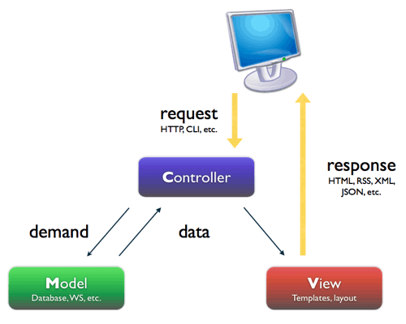

Figure : MVC Architecture

**(http://smist08.wordpress.com/tag/mvc/)**

**The Model** is the part of the application that handles the logic for the application data.  
Often model objects retrieve data (and store data) from a database.

**The View** is the parts of the application that handles the display of the data.  
Most often the views are created from the model data.

**The Controller** is the part of the application that handles user interaction.  
Typically controllers read data from a view, control user input, and send input data to the model.

**(**<http://www.w3schools.com/aspnet/mvc_intro.asp>**)**

### Description of System Interface

#### User interfaces

* Web-based user interfaces that rely on Bootstrap. Focusing on user experience

#### Hardware interfaces

* The OMCS is intended as a website runs well on all modern web browsers. The website should be deployed online and accessible on any computer using different Operation Systems. At present, OMCS does not have mobile version.

#### Software interfaces

* The system should be able to run on any browser supported HTML 5.
* Any service exposed by the system should be accessible using HTTP protocol.

#### Communication interfaces

* The system uses HTTP protocol to communicate between server and clients.

## Component Diagram

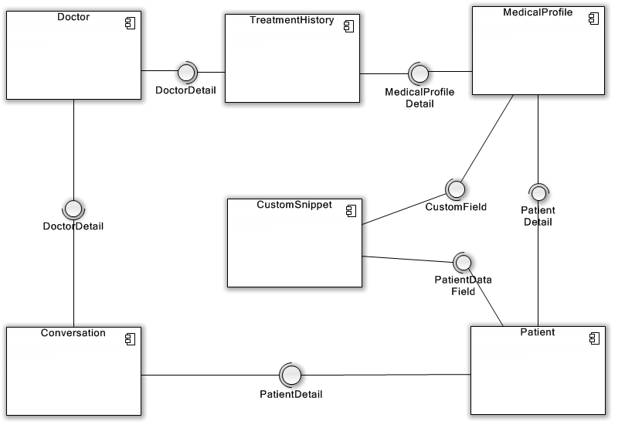

Figure 2: Component Diagram

## Detailed Description of Components

### Class Diagram

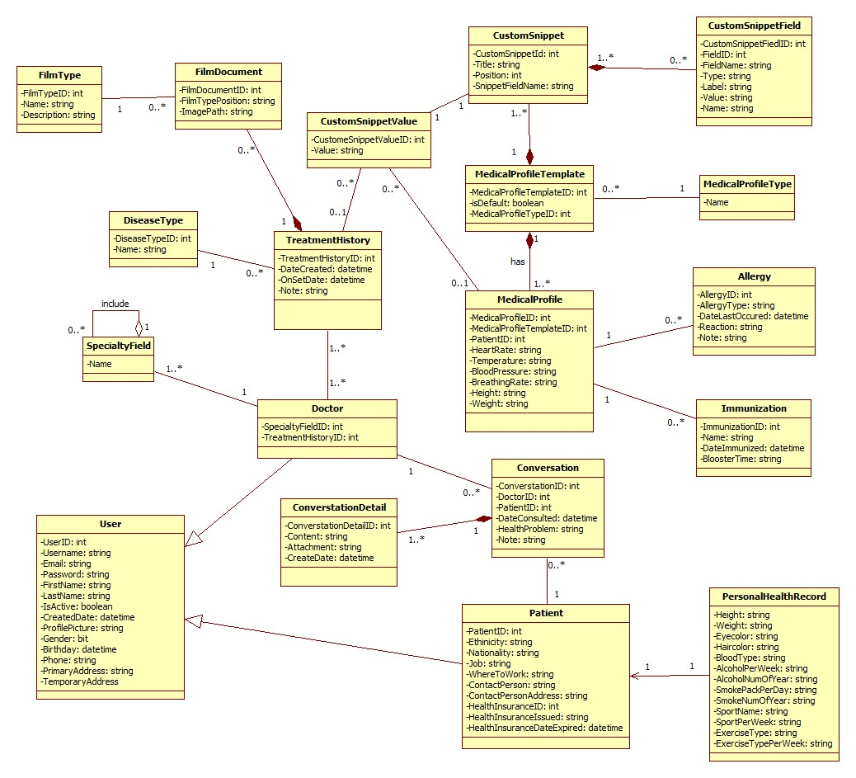

Figure 3: Class Diagram

## Sequence Diagram

### <Guest> Login

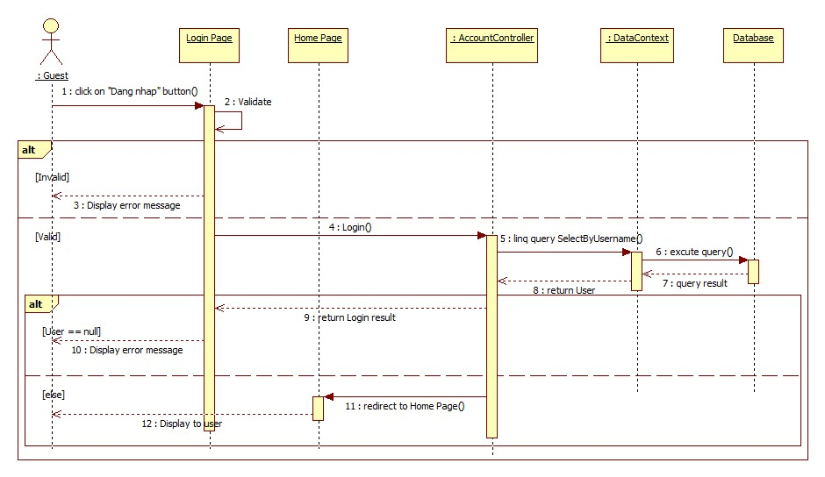

Figure 4: <Guest> Login Sequence Diagram

### <Guest> Register

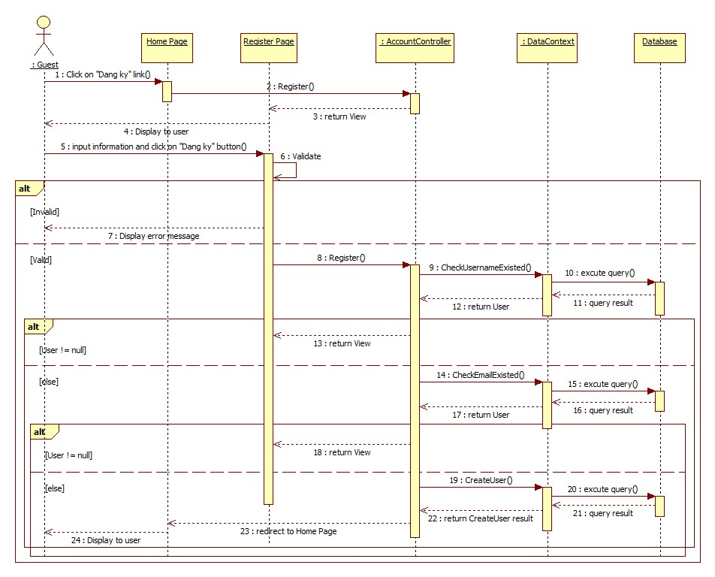

Figure 5: <Guest> Register Sequence Diagram

### <Authorized User> Change Password

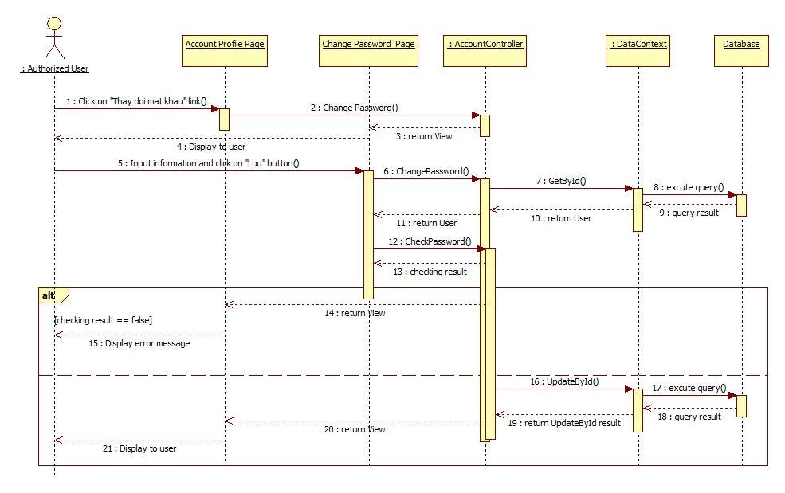

Figure 6: <Authorized User> Change Password Sequence Diagram

### <Authorized User> Change Profile Picture

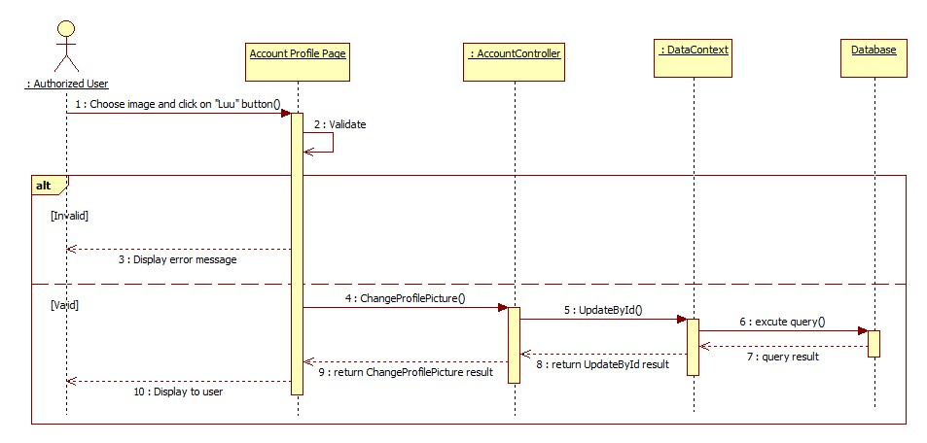

Figure 7: <Authorized User> Change Profile Picture Sequence Diagram

### <Patient> Conversation

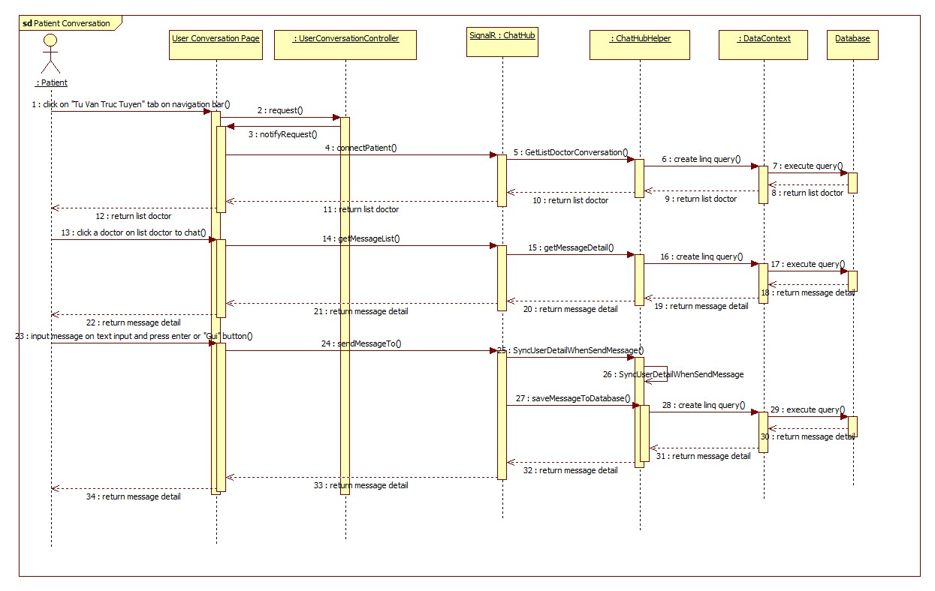

Figure 8: <Patient> Conversation Sequence Diagram

### <Doctor> Request Webcam

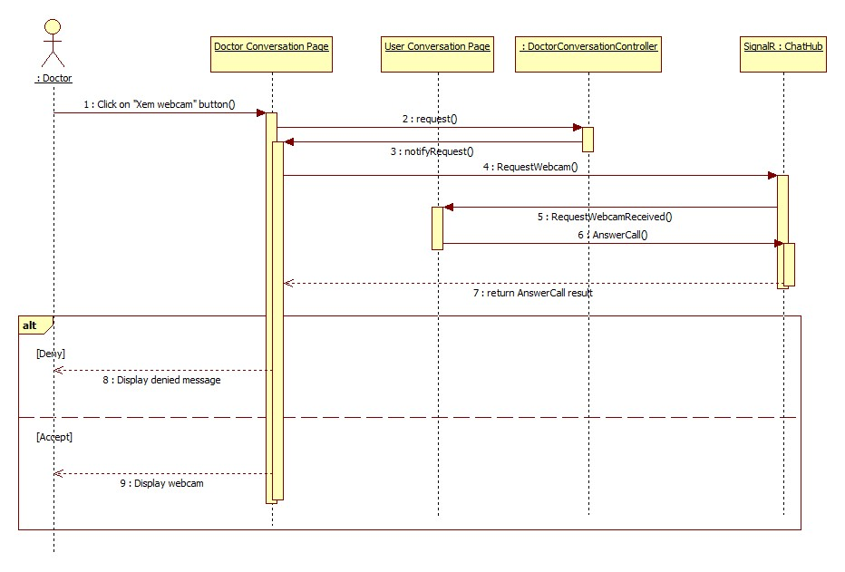

Figure 9: <Doctor> Request Webcam Sequence Diagram

### <Patient> Show Webcam

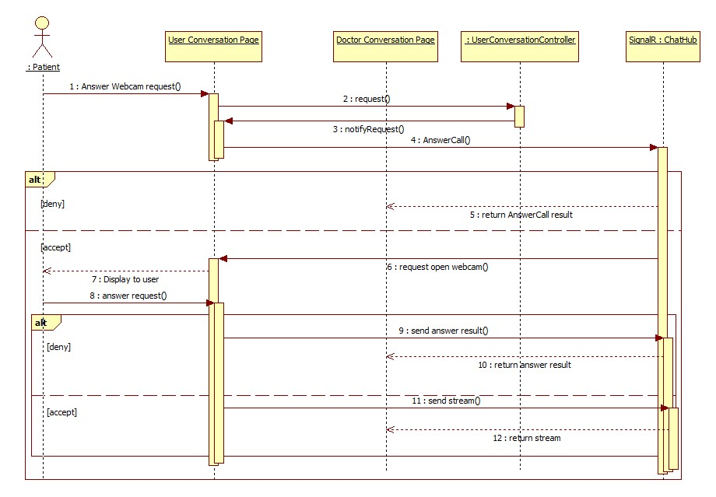

Figure 10: <Patient> Show Webcam

### <Patient> Upload Attachment

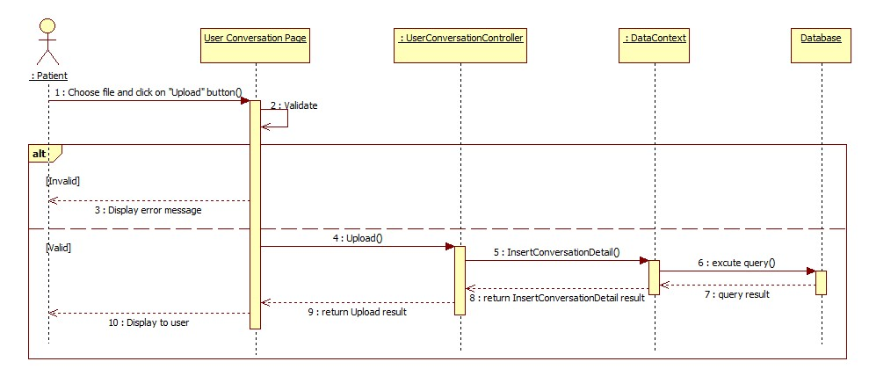

Figure 11: <Patient> Upload Attachment

### <Admin> Define New Medical Profile Template

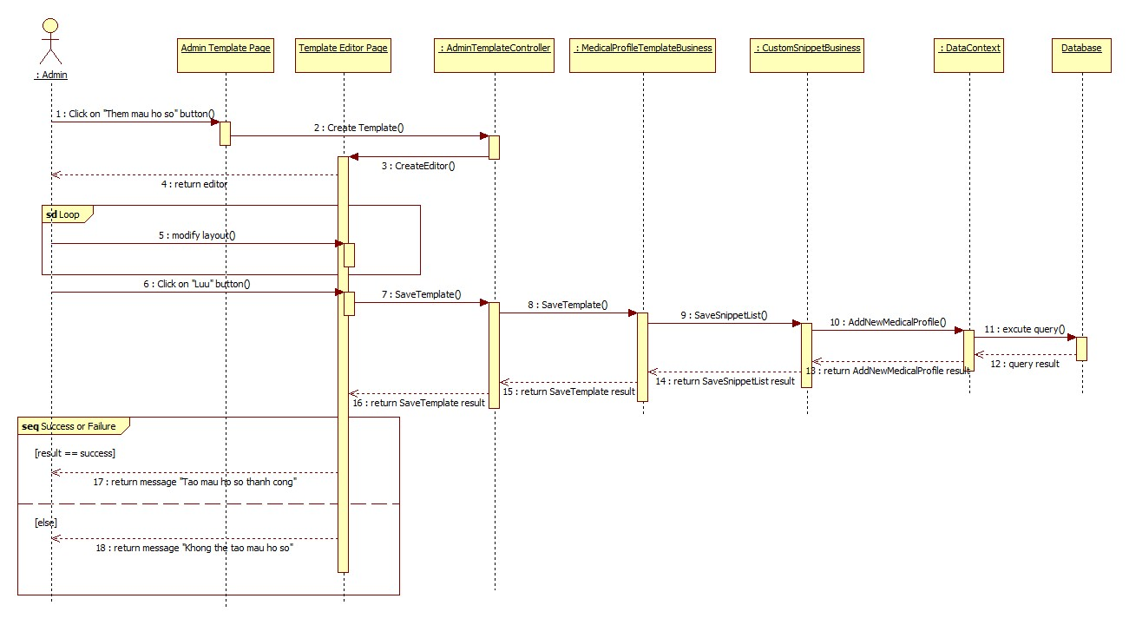

Figure 12: <Admin> Define New Medical Profile Template

### <Admin> Update Medical Profile Template

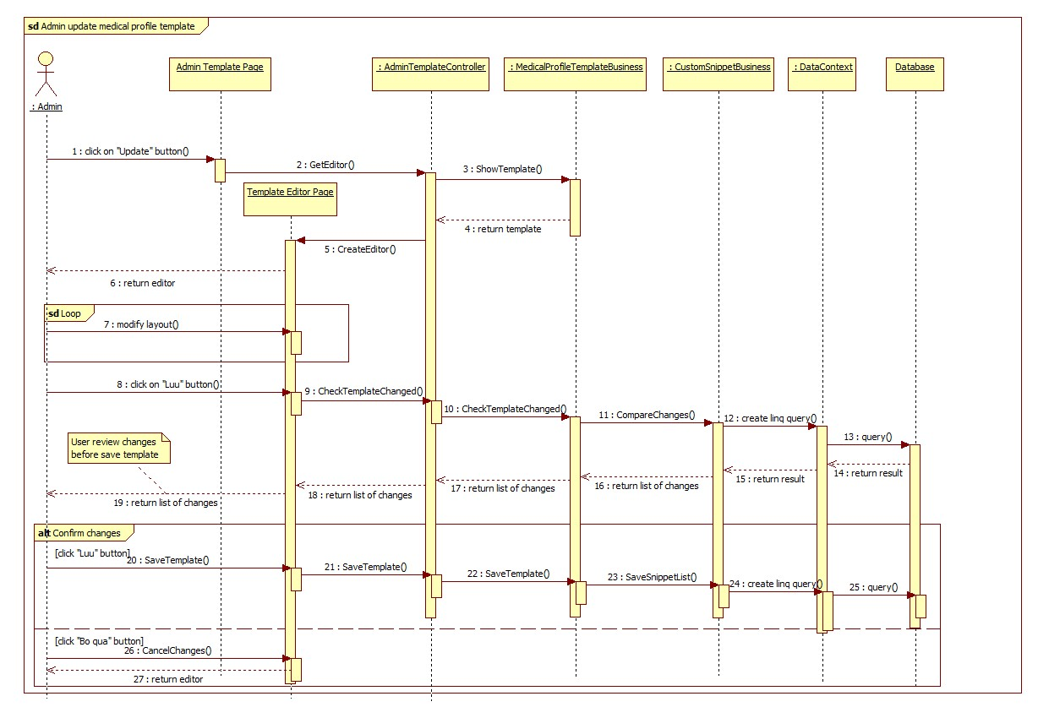

### <Doctor> Update Medical Profile

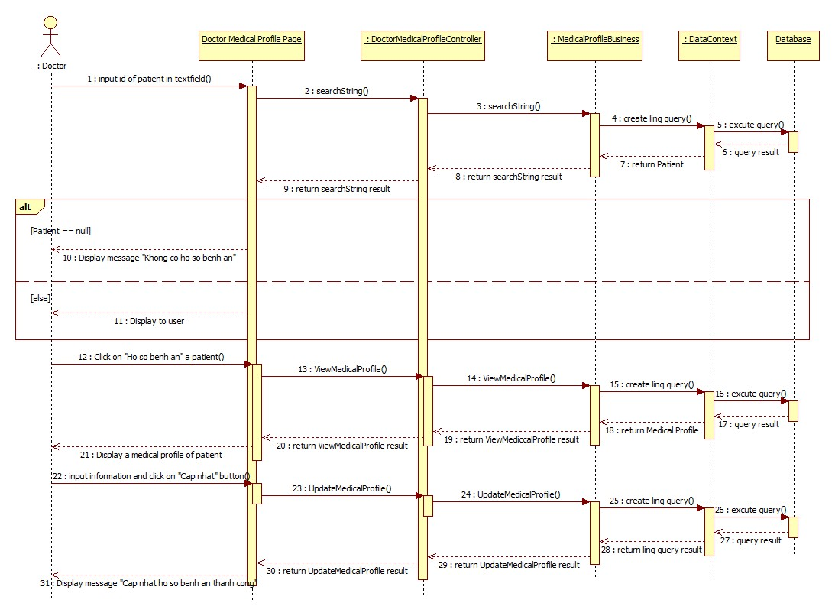

Figure : <Doctor> Update Medical Profile

### <Doctor> Views Medical Profile

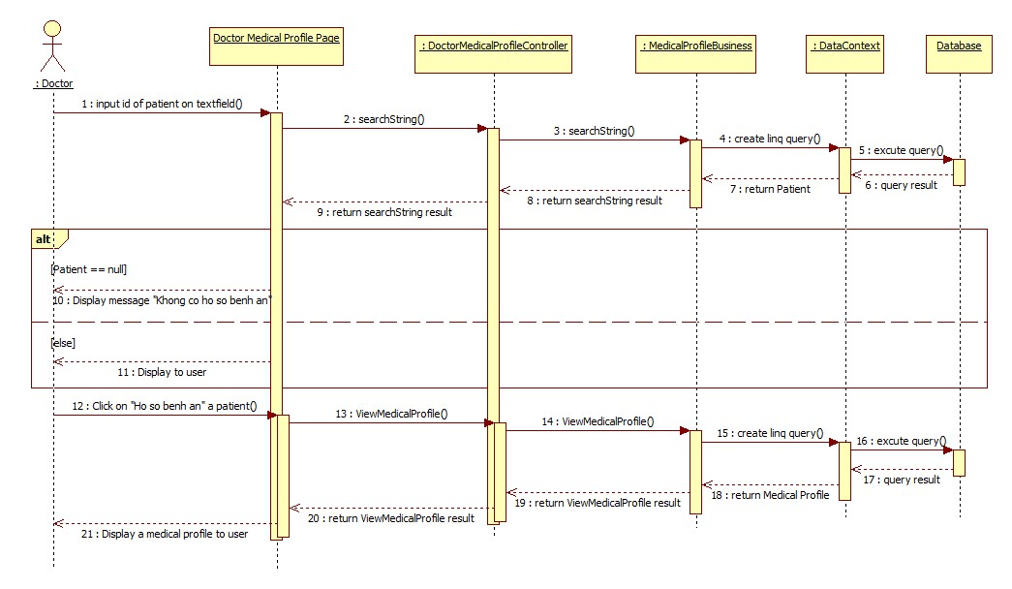

Figure 14: <Doctor> Views Medical Profile

### <Patient> Update Personal Health Record

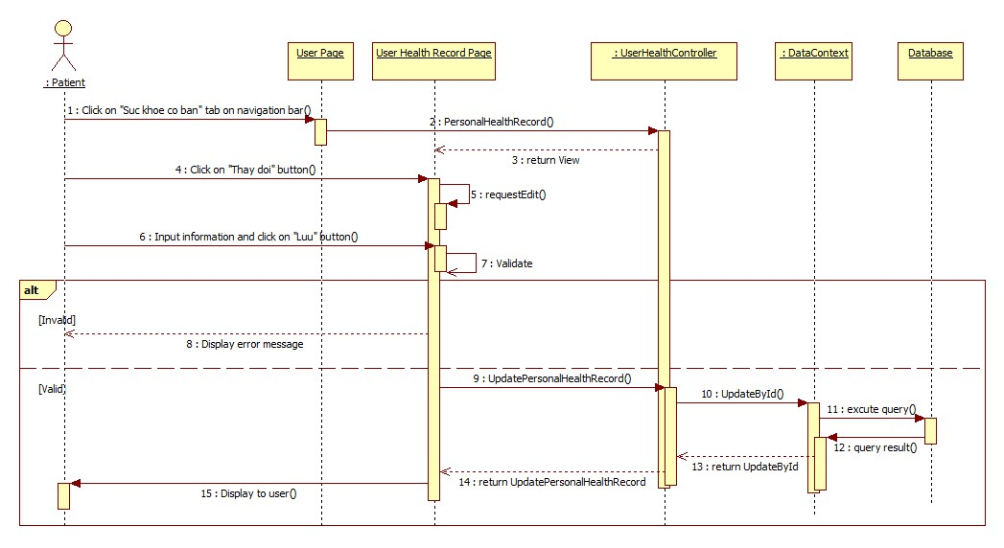

Figure : <Patient> Update Personal Health Record

### <Patient> View medical Profile Record

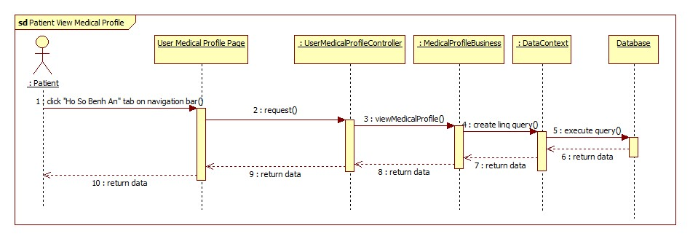

Figure 9: <Patient> View Medical Profile Record

## User Interface Design

## Database Design

